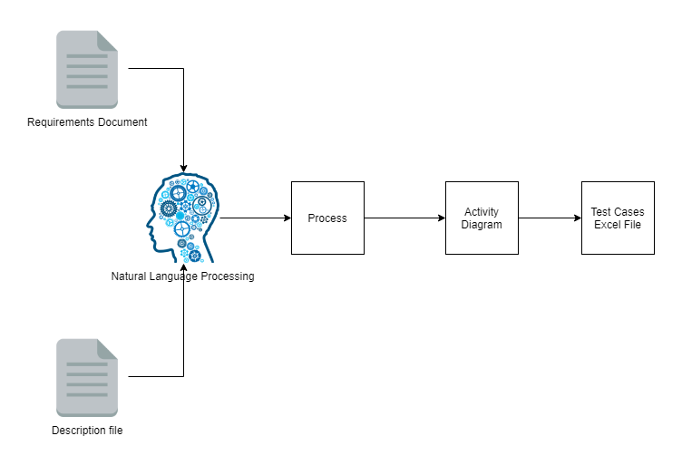

Description:

* **Requirements Document:** A document with all the requirement’s titles, descriptions and IDs.
* **Description file:** File with all test cases descriptions and the requirements for each of it.
* **Natural Language Processing:** The description file will be split in sentences and all of them will be classified as test case description, requirement and so on.
* **Process:** this component will process all the input files. For the requirements document, we will get all the requirement’s title, description and id. Will receive all the classified sentences by the natural language processing. And will save all the data and relationships in a data structure.
* **Activity diagram:** Will interpret the previous data structure and will create an activity diagram without arrows. The arrows will be insert manually (to avoid chronological order between steps).
* **Test Cases Excel File:** After the activity diagram creation will be tested all the possible workflows. All the workflows will correspond to a test case. All the steps and expected results will be generated by this workflows interpretation.